UNIT I BASIC NETWORK CONNECTIVITY AND COMMUNICATION

Network Today: Network Components-Network Representation and Toplogies-Common Types of Networks-Internet Connections-Reliable Networks-Network Trends-Security Threats and Solutions.

Basic Switch And End Device Configuration: IOS Access-IOS Navigation-The command Structure-Basic Device Configuration-Save Configuration-Ports and Addresses-Configure IP Addressing.

Protocols and Models: Introduction-The Rules-Protocols-Protocol Suites-Standards-Organizations-Reference Models-Data Encapsulation- Data Access.

  - Network Today
When we communicate, we are sharing information. This sharing can be local or remote.
The term telecommunication, which includes telephony, telegraphy, and television, means communication at a distance (tele is Greek for "far").
The word data refers to information presented in whatever form is agreed upon by the parties creating and using the data.

“Networks are the exchange of data between two devices via some form of transmission medium such as a wire cable”.
For network communications to occur, the communicating devices must be part of a communication system made up of a combination of hardware (physical equipment) and software (programs).
The effectiveness of a network communications system depends on four fundamental characteristics:
I. Delivery: The system must deliver data to the correct destination. Data must be received by the intended device or user .
- Accuracy: The system must deliver the data accurately. Data that have been altered in transmission and left uncorrected are unusable.

- Timeliness: The system must deliver data in a timely manner. Data delivered late are useless.

- Jitter: Jitter refers to the variation in the packet arrival time. It is the uneven delay in the delivery of audio or video packets.

    - Network Components

A Network communications system has five components
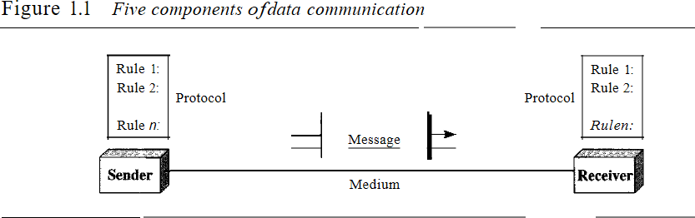

- Message: The message is the information (data) to be communicated.
- Sender: The sender is the device that sends the data message. It can be a computer, workstation, telephone handset, video camera, and so on.

- Receiver: The receiver is the device that receives the message. It can be a computer, workstation, telephone handset, television, and so on.

- Transmission medium: The transmission medium is the physical path by which a message travels from sender to receiver. Some examples of transmission media include twisted-pair wire, coaxial cable, fiber optic cable, and radio waves.

- Protocol: A protocol is a set of rules that govern data communications. It represents an agreement between the communicating devices. Without a protocol, two devices may be connected but not communicating.

    - Network Representation and Topologies
Information today comes in different forms such as text, numbers, images, audio, and video.

Text
In data communications, text is represented as a bit pattern, a sequence of bits (O s or 1 s). Different sets of bit patterns have been designed to represent text symbols. Each set is called a code, and the process of representing symbols is called coding.
Unicode, which uses 32 bits to represent a symbol or character used in any language in the world. The American Standard Code for Information Interchange (ASCII), now constitutes the first 127 characters in Unicode and is also referred to as Basic Latin.

Numbers
Numbers are also represented by bit patterns. However, a code such as ASCII is not used to represent numbers; the number is directly converted to a binary number to simplify mathematical operations.

Images
Images are also represented by bit patterns. In its simplest form, an image is composed of a matrix of pixels (picture elements), where each pixel is a small dot. The size of the pixel depends on the resolution. The size and the value of the pattern depend on the image.

For an image made of only black-and-white dots (e.g., a chessboard), a I-bit pattern is enough to represent a pixel. If an image is not made of pure white and pure black pixels, you can increase the size of the bit pattern to include gray scale
There are several methods to represent color images. One method is called RGB, so called because each color is made of a combination of three primary colors: red, green, and blue. The intensity of each color is measured, and a bit pattern is assigned to it. Another method is called YCM, in which a color is made of a combination of three other primary colors: yellow, cyan, and magenta.

Audio
Audio refers to the recording or broadcasting of sound or music. Audio is by nature different from text, numbers, or images.

Video

Video refers to the recording or broadcasting of a picture or movie. Video can either be produced as a continuous entity (e.g., by a TV camera), or it can be a combination of images, each a discrete entity, arranged to convey the idea of motion
A network is a set of devices (often referred to as nodes) connected by communication links. A node can be a computer, printer, or any other device capable of sending and/or receiving data generated by other nodes on the network.

Distributed Processing
Most networks use distributed processing, in which a task is divided among multiple computers. Instead of one single large machine being responsible for all aspects of a process, separate computers (usually a personal computer or workstation) handle a subset.

A network must be able to meet a certain number of criteria. The most important of these are performance, reliability, and security.

Performance
Performance can be measured in many ways, including transit time and response time. Transit time is the amount of time required for a message to travel from one device to another. Response time is the elapsed time between an inquiry and a response. The performance of a network depends on a number of factors, including the number of users, the type of transmission medium, the capabilities of the connected hardware, and the efficiency of the software. Performance is often evaluated by two networking metrics: throughput and delay. Throughput is an actual measurement of how fast data can be transmitted. Latency/delay is time required for a message to completely arrive at the destination from source. We often need more throughput and less delay. However, these two criteria are often contradictory. If we try to send more data to the network, we may increase throughput but we increase the delay because of traffic congestion in the network.

Reliability
In addition to accuracy of delivery, network reliability is measured by the frequency of failure, the time it takes a link to recover from a failure, and the network's robustness in a catastrophe.

Security
Network security issues include protecting data from unauthorized access, protecting data from damage and development, and implementing policies and procedures for recovery from breaches and data losses.

A network is two or more devices connected through links. A link is a communications pathway that transfers data from one device to another. There are two possible types of connections: point-to-point and multipoint.

Point-to-Point
A point-to-point connection provides a dedicated link between two devices. The entire capacity of the link is reserved for transmission between those two devices. Most point-to-point connections use an actual length of wire or cable to connect the two ends (see Figure 1.3a).
When you change television channels by infrared remote control, you are establishing a point- to-point connection between the remote control and the television's control system. Multipoint A multipoint (also called multidrop) connection is one in which more than two specific devices share a single link (see Figure 1.3b). In a multipoint environment, the capacity of the channel is shared, either spatially or temporally. If several devices can use the link simultaneously, it is a spatially shared connection. If users must take turns, it is a timeshared connection.
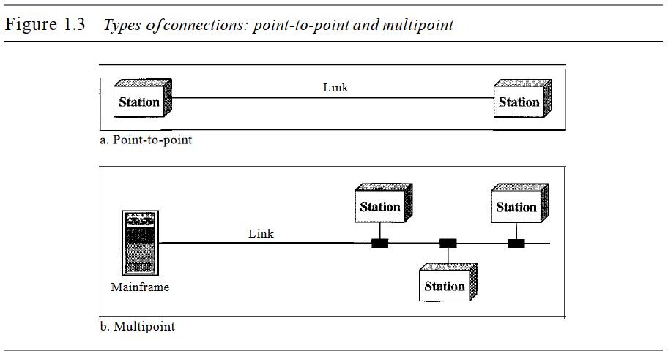

Physical Topology

The term physical topology refers to the way in which a network is laid out physically. Two or more devices connect to a link; two or more links form a topology. The topology of a network is the geometric representation of the relationship of all the links and linking devices (usually called nodes) to one another. There are four basic topologies possible: mesh, star, bus, and ring (see Figure 1.4).

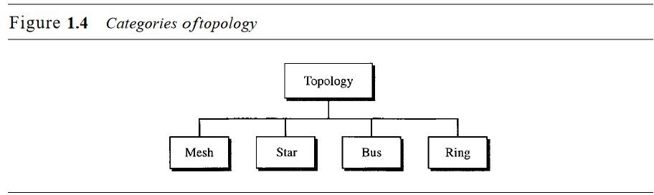
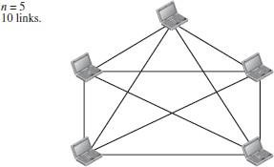

Mesh Topology

- In a mesh topology, every device has a dedicated point-to-point link to everyother device.
- The term dedicated means that the link carries traffic only between the twodevices it connects.
- The number of physical links in a fully connected mesh network with n
nodes isgiven by n (n – 1) / 2.


Star Topology
1.

2.
3.
4.
Advantages of Mesh Topology
Each connection can carry its own data load.
It is robust.
Fault is diagnosed easily. Provides security and privacy.
1.
2.
3.
Disadvantages of Mesh Topology
Installation and configuration is difficult.
Cabling cost is more. Bulk wiring is required.
      - In a star topology, each device has a dedicated point-to-point link only to a central controller, usually called a hub.
      - The devices are not directly linked to one another.

      - The controller/hub acts as an exchange.
      - If one device wants to send data to another, it sends the data to the controller/hub ,which then relays the data to the other connected device.

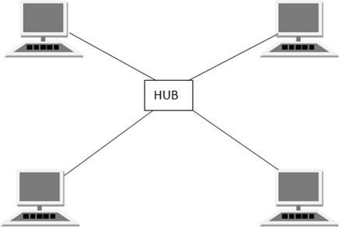
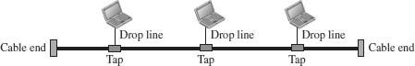

Disadvantages of Star Topology
- Cost of installation is high.
- Expensive to use.
- If the hub fails, then the wholenetwork is stopped.
- Performance is based on the hub thatis it depends on its capacity
Advantages of Star Topology
- Fast performance with few nodes and low network traffic.
- Hub can be upgraded easily.
- Easy to troubleshoot.
- Easy to setup and modify.
- Only that node is affected which has failed, rest of the nodes can work smoothly

Bus

Topology

- Bus topology is a network type in which every computer and network device isconnected to single cable.
- The long single cable acts as a backbone to link all the devices in a network.
- When it has exactly two endpoints, then it is called Linear Bus topology.
- It transmits data only in one direction.

Disadvantages of Bus Topology
- Cables fails then whole network fails. If
- network traffic is heavy or nodes are more, the performance of the network decreases.
- Cable has a limited length.
- It is slower than the ring topology.
Advantages of Bus Topology
- It is cost effective.
- Cable required is least compared to other network topology.
- Used in small networks.
- It is easy to understand.
- Easy to expand joining two cables together

Ring Topology

      - In a ring topology, each device has a dedicated point-to-point connection withonly the two devices on either side of it.
      - A signal is passed along the ring in one direction, from device to device, until itreaches its destination.
      - Each device in the ring incorporates a repeater.

      - When a device receives a signal intended for another device, its repeater regenerates the bits and passes them along.
Disadvantages of Ring Topology
- Troubleshooting is difficult in ring topology.
- Adding or deleting the computers disturbs the network activity.
- Failure of one computer disturbs the whole network
Advantages of Ring Topology
- Transmitting network is not affected by high traffic or by adding more nodes, as only the nodes having tokens can transmit data.
- Cheap to install and expand
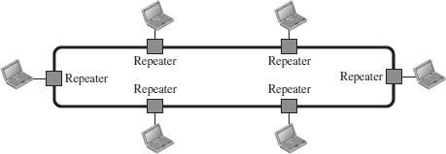
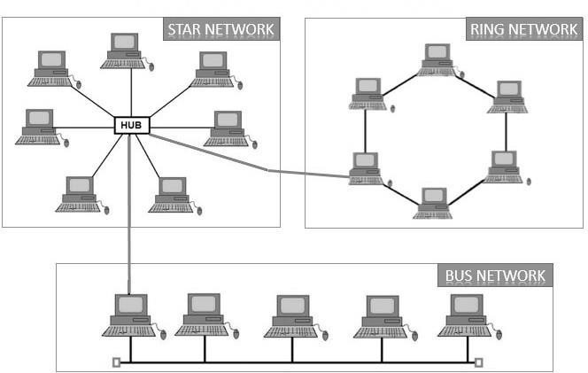
Disadvantages of Hybrid Topology
- Complex in design.
- Costly
Advantages of Hybrid Topology
- Reliable as Error detecting and trouble shooting is easy.
- Effective.
- Scalable as size can be increased easily.
- Flexible.

Hybrid Topology
- Hybrid Topology is a combination of one or more basic topologies.
- For example if one department in an office uses ring topology, the other departments uses star and bus topology, then connecting these topologies will result in Hybrid Topology.
- Hybrid Topology inherits the advantages and disadvantages of the topologies included.

1.1.3 Common Types of Networks
interconnecting a different LAN to form a larger network.
- It generally covers towns and cities (50 km)
- In MAN, various LANs are connected to each other through a telephone exchange line.
- Communication medium used for MAN are optical fibers, cables etc.
- It has a higher range than Local Area Network(LAN).It is adequate for distributed computing applications.
Different types of networks: LANs MANs and WANs.
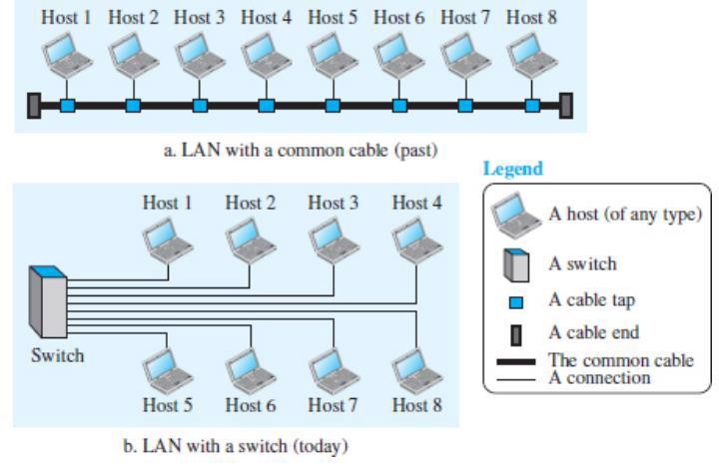
Local Area Network
□
Local Area Network is a group of computers connected to each other in a small area such as building, office.
      - LAN is used for connecting two or more personal computers through a communication medium such as twisted pair, coaxial cable, etc.
      - It is less costly as it is built with inexpensive hardware such as hubs, networkadapters, and ethernet cables.
      - The data is transferred at an extremely faster rate in Local Area Network.
      - LAN can be connected using a common cable or a Switch
Disadvantages of LAN
- High Setup Cost
- Privacy Violations Data
- Security Threat LAN
- Maintenance Job
- Covers Limited Area
Advantages of LAN
- Resource Sharing
- Software Applications Sharing.
- Easy and Cheap Communication
- Centralized Data.
- Data Security
- Internet Sharing

Metropolitan Area Network (MAN)
      - A metropolitan area network is a network that covers a larger geographic area by

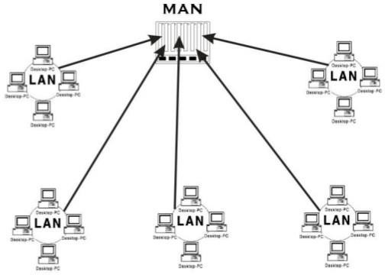

Point-to-Point WAN
A point-to-point WAN is a network that connects two communicating devices through a transmission medium (cable or air). Figure 1.9 shows an example of a point-to-point WAN.

Wide Area Network (WAN)
      - A Wide Area Network is a network that extends over a large geographical areasuch as states or countries.
      - A Wide Area Network is quite bigger network than the LAN.
      - A Wide Area Network is not limited to a single location, but it spans over a largegeographical area through a telephone line, fibre optic cable or satellite links.
      - The internet is one of the biggest WAN in the world.
      - A Wide Area Network is widely used in the field of Business, government, andeducation.
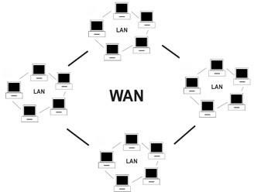
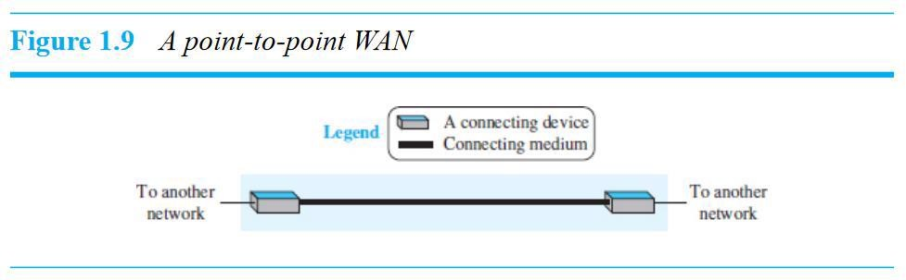
      - WAN can be either a point-to-point WAN or Switched WAN.

Switched WAN
A switched WAN is a network with more than two ends. It is used in the backbone of a global communications network today. Figure 1.10 shows an example of a switched WAN
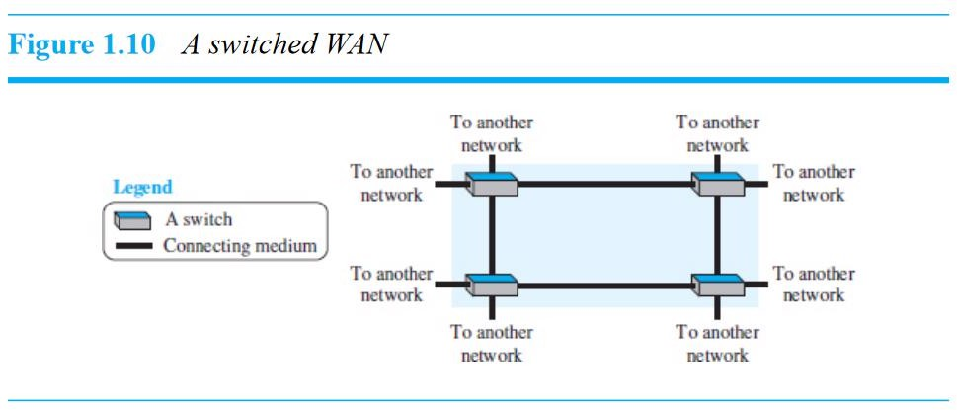
Advantages of Wide Area Network:
Large Geographical area Centralized data
o o o o o
Exchange messages
Sharing of software and resources High bandwidth
Disadvantages of Wide Area Network:
Security issue
o o o o
Needs Firewall & antivirus software High Setup cost
Troubleshooting problems

Internetwork
Today, it is very rare to see a LAN or a WAN in isolation; they are connected to one another. When two or more networks are connected, they make an internetwork, or internet. As an example, assume that an organization has two offices, one on the east coast and the other on the west coast.
Each office has a LAN that allows all employees in the office to communicate with each other. To make the communication between employees at different offices possible, the management leases a point-to-point dedicated WAN from a service provider, such as a telephone company, and connects the two LANs.
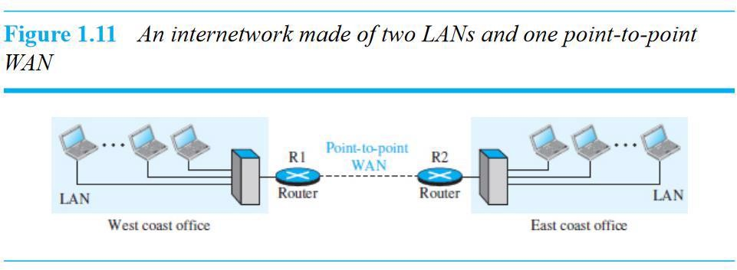
Now the company has an internetwork, or a private internet (with lowercase i).
Communication between offices is now possible. Figure 1.11 shows this internet.
Types of Internetwork

Extranet | Intranet
An extranet is used for information sharing. The access to the extranet is restricted to only those users who have login credentials. An extranet is the lowest level of internetworking. It can becategorized as MAN, WAN or other computer networks. An extranet cannot have a single LAN, atleast it must haveone connection to the external network. | An intranet belongs to an organization which is only accessible by the organization's employee or members. The main aim of the intranet is to share the information and resources among the organization employees. An intranet provides the facility to work in groups and for teleconferences.

1.1.4 Internet Connections
An internet (note the lowercase i) is two or more networks that can communicate with each other. The most notable internet is called the Internet (uppercase I) and is composed of thousands of interconnected networks. Figure 1.13 shows a conceptual (not geographical) view of the Internet.

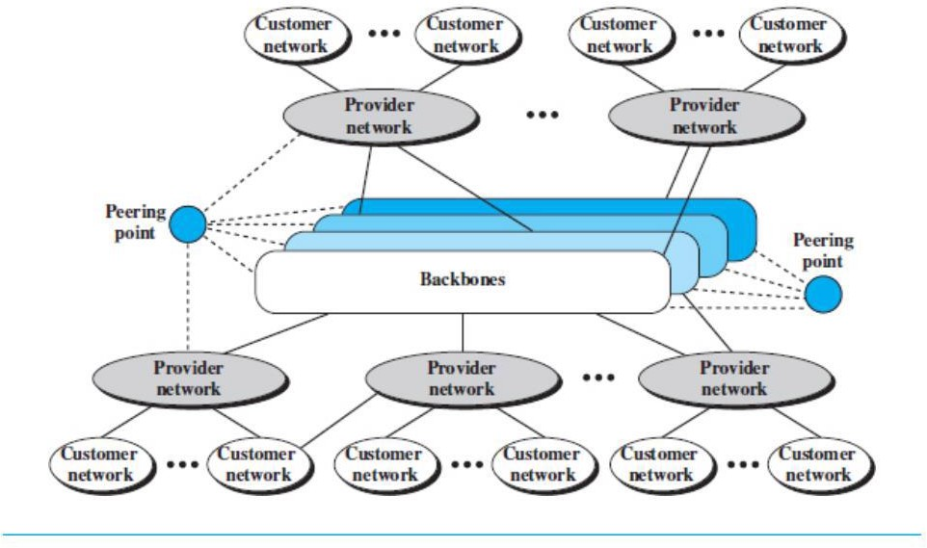

The figure shows the Internet as several backbones, provider networks, and customer networks. At the top level, the backbones are large networks owned by some communication companies. The backbone networks are connected through some complex switching systems, called peering points.
At the second level, there are smaller networks, called provider networks, that use the services of the backbones for a fee. The provider networks are connected to backbones and sometimes to other provider networks. The customer networks are networks at the edge of the Internet that actually use the services provided by the Internet. They pay fees to provider networks for receiving services.

Backbones and provider networks are also called Internet Service Providers (ISPs). The backbones are often referred to as international ISPs; the provider networks are often referred to as national or regional ISPs.

Accessing the Internet
The Internet today is an internetwork that allows any user to become part of it. The user, however, needs to be physically connected to an ISP. The physical connection is normally done through a point-to-point WAN (such as a telephone network, a cable network, a wireless network, or other types of networks).

1.1.5 Reliable Networks

Using Telephone Networks
Today most residences and small businesses have telephone service, which means they are connected to a telephone network. Because most telephone networks have already connected themselves to the Internet, one option for residences and small businesses to connect to the Internet is to change the voice line between the residence or business and the telephone center to a point-to-point WAN. This can be done in two ways.
❏ Dial-up service. The first solution is to add a modem that converts data to voice to the telephone line. The software installed on the computer dials the ISP and imitates making a telephone connection. Unfortunately, the dial-up service is very slow, and when the line is used for an Internet connection, it cannot be used for a telephone (voice)connection. It is only useful for small residences and businesses with occasional connection to the Internet.
❏ DSL Service. Since the advent of the Internet, some telephone companies have upgraded their telephone lines to provide higher-speed Internet services to residences or small businesses. The digital subscriber line (DSL) service also allows the line to be used simultaneously for voice and data communications.

Using Cable Networks
More and more residents over the last two decades have begun using cable TV services instead of antennas to receive TV broadcasting. The cable companies have been upgrading their cable networks and connecting to the Internet. A residence or a small business can be connected to the Internet by using this service. It provides a higher-speed connection, but the speed varies depending on the number of neighbors that use the same cable.

Using Wireless Networks
Wireless connectivity has recently become increasingly popular. A household or a small business can use a combination of wireless and wired connections to access the Internet. With the growing wireless WAN access, a household or a small business can be connected to the Internet through a wireless WAN.

Direct Connection to the Internet

A large organization or a large corporation can itself become a local ISP and be connected to the Internet. This can be done if the organization or the corporation leases a high-speed WAN from a carrier provider and connects itself to a regional ISP. For example, a large university with several campuses can create an internetwork and then connect the internetwork to the Internet.

1.1.6 Network Trends

Bring Your Own Device (BYOD)
The concept of any device, for any content, in any manner, is a major global trend that requires significant changes to the way we use devices and safely connect them to networks. This is called Bring Your Own Device (BYOD).

BYOD enables end users the freedom to use personal tools to access information and communicate across a business or campus network. With the growth of consumer devices, and the related drop in cost, employees and students may have advanced computing and networking devices for personal use. These include laptops, notebooks, tablets, smart phones, and e-readers. These may be purchased by the company or school, purchased by the individual, or both.

BYOD means any device, with any ownership, used anywhere.

Online Collaboration
Individuals want to connect to the network, not only for access to data applications, but also to collaborate with one another. Collaboration is defined as “the act of working with another or others on a joint project.” Collaboration tools, like Cisco WebEx, shown in the figure, give employees, students, teachers, customers, and partners a way to instantly connect, interact, and achieve their objectives.
Video Communications
Another facet of networking that is critical to the communication and collaboration effort is video. Video is used for communications, collaboration, and entertainment. Video calls are made to and from anyone with an internet connection, regardless of where they are located.
Video conferencing is a powerful tool for communicating with others, both locally and globally. Video is becoming a critical requirement for effective collaboration as organizations extend across geographic and cultural boundaries.
Wireless Broadband
In many areas where cable and DSL are not available, wireless may be used to connect to the internet.
Wireless Internet Service Provider
A Wireless Internet Service Provider (WISP) is an ISP that connects subscribers to a designated access point or hot spot using similar wireless technologies found in home wireless local area networks (WLANs). WISPs are more commonly found in rural environments where DSL or cable services are not available.
Although a separate transmission tower may be installed for the antenna, typically the antenna is attached to an existing elevated structure, such as a water tower or a radio tower. A small dish or antenna is installed on the subscriber’s roof in range of the WISP transmitter. The subscriber’s access unit is connected to the wired network inside the home. From the perspective of the home user, the setup is not much different than DSL or cable service. The main difference is that the connection from the home to the ISP is wireless instead of a physical cable.

1.1.7 Security Threats and Solutions

You have, no doubt, heard or read news stories about a company network being breached, giving threat actors access to the personal information of thousands of customers. For this reason, network security is always going to be a top priority of administrators.
Network security is an integral part of computer networking, regardless of whether the network is in a home with a single connection to the internet or is a corporation with thousands of users. Network security must consider the environment, as well as the tools and requirements of the network. It must be able to secure data while still allowing for the quality of service that users expect of the network.
Securing a network involves protocols, technologies, devices, tools, and techniques in order to protect data and mitigate threats. Threat vectors may be external or internal. Many external network security threats today originate from the internet.
There are several common external threats to networks:
- Viruses, worms, and Trojan horses - These contain malicious software or code running on a user device.
- Spyware and adware - These are types of software which are installed on a user’s device. The software then secretly collects information about the user.
- Zero-day attacks - Also called zero-hour attacks, these occur on the first day that a vulnerability becomes known.
- Threat actor attacks - A malicious person attacks user devices or network resources.
- Denial of service attacks - These attacks slow or crash applications and processes on a network device.
- Data interception and theft - This attack captures private information from an organization’s network.
- Identity theft - This attack steals the login credentials of a user in order to access private data.
It is equally important to consider internal threats. There have been many studies that show that the most common data breaches happen because of internal users of the network. This can be attributed to lost or stolen devices, accidental misuse by employees, and in the business environment, even malicious employees. With the evolving BYOD strategies, corporate data is much more vulnerable. Therefore, when developing a security policy, it is important to address both external and internal security threats,
Security Solutions
No single solution can protect the network from the variety of threats that exist. For this reason, security should be implemented in multiple layers, using more than one security solution. If one security component fails to identify and protect the network, others may succeed.
A home network security implementation is usually rather basic. Typically, you implement it on the end devices, as well as at the point of connection to the internet, and can even rely on contracted services from the ISP.
These are the basic security components for a home or small office network:
- Antivirus and antispyware - These applications help to protect end devices from becoming infected with malicious software.
- Firewall filtering - Firewall filtering blocks unauthorized access into and out of the network. This may include a host-based firewall system that prevents unauthorized access to the end device, or a basic filtering service on the home router to prevent unauthorized access from the outside world into the network.
In contrast, the network security implementation for a corporate network usually consists of many components built into the network to monitor and filter traffic. Ideally, all components work together, which minimizes maintenance and improves security. Larger networks and corporate networks use antivirus, antispyware, and firewall filtering, but they also have other security requirements:
- Dedicated firewall systems - These provide more advanced firewall capabilities that can filter large amounts of traffic with more granularity.
- Access control lists (ACL) - These further filter access and traffic forwarding based on IP addresses and applications.
- Intrusion prevention systems (IPS) - These identify fast-spreading threats, such as zero-day or zero-hour attacks.
- Virtual private networks (VPN) - These provide secure access into an organization for remote workers.
Network security requirements must consider the environment, as well as the various applications, and computing requirements. Both home and business environments must be able to secure their data while still allowing for the quality of service that users expect of each technology. Additionally, the security solution implemented must be adaptable to the growing and changing trends of the network.
The study of network security threats and mitigation techniques starts with a clear understanding of the underlying switching and routing infrastructure used to organize network services.

1.2 Basic Switch and End Device Configurations

1.2.1 IOS Access

Operating Systems
All end devices and network devices require an operating system (OS). As shown in the figure, the portion of the OS that interacts directly with computer hardware is known as the kernel. The portion that interfaces with applications and the user is known as the shell. The user can interact with the shell using a command-line interface (CLI) or a graphical user interface (GUI).
- Shell - The user interface that allows users to request specific tasks from the computer. These requests can be made either through the CLI or GUI interfaces.
- Kernel - Communicates between the hardware and software of a computer and manages how hardware resources are used to meet software requirements.
- Hardware - The physical part of a computer including underlying electronics.

When using a CLI, the user interacts directly with the system in a text-based environment by entering commands on the keyboard at a command prompt, as shown in the example. The system executes the command, often providing textual output. The CLI requires very little overhead to operate. However, it does require that the user have knowledge of the underlying command structure that controls the system.

GUI
A GUI such as Windows, macOS, Linux KDE, Apple iOS, or Android allows the user to interact with the system using an environment of graphical icons, menus, and windows. The GUI example in the figure is more user-friendly and requires less knowledge of the underlying command structure that controls the system. For this reason, most users rely on GUI environments.
Purpose of an OS
Network operating systems are similar to a PC operating system. Through a GUI, a PC operating system enables a user to do the following:
- Use a mouse to make selections and run programs
- Enter text and text-based commands
- View output on a monitor
A CLI-based network operating system (e.g., the Cisco IOS on a switch or router) enables a network technician to do the following:
- Use a keyboard to run CLI-based network programs
- Use a keyboard to enter text and text-based commands
- View output on a monitor
Cisco networking devices run particular versions of the Cisco IOS. The IOS version is dependent on the type of device being used and the required features. While all devices come with a default IOS and feature set, it is possible to upgrade the IOS version or feature set to obtain additional capabilities.
Access Methods
A switch will forward traffic by default and does not need to be explicitly configured to operate. For example, two configured hosts connected to the same new switch would be able to communicate.
Regardless of the default behavior of a new switch, all switches should be configured and secured.
Terminal Emulation Programs
There are several terminal emulation programs you can use to connect to a networking device either by a serial connection over a console port, or by an SSH/Telnet connection. These programs allow you to enhance your productivity by adjusting window sizes, changing font sizes, and changing color schemes.
SecureCRT
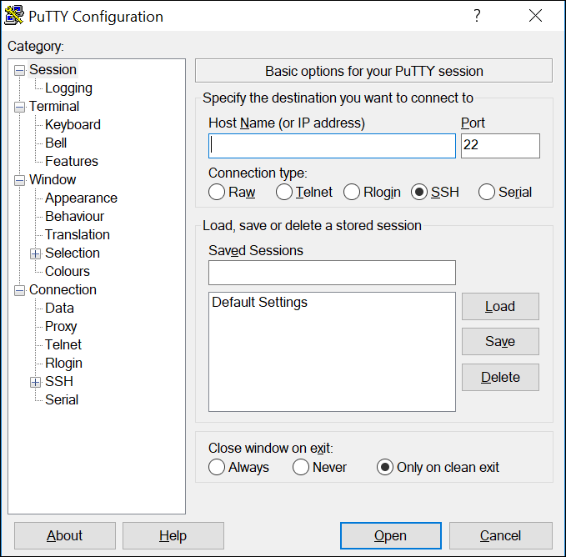

1.2.2 IOS Navigation

Primary Command Modes
In the previous topic, you learned that all network devices require an OS and that they can be configured using the CLI or a GUI. Using the CLI may provide the network administrator with more precise control and flexibility than using the GUI. This topic discusses using CLI to navigate the Cisco IOS.
As a security feature, the Cisco IOS software separates management access into the following two command modes:
- User EXEC Mode - This mode has limited capabilities but is useful for basic operations. It allows only a limited number of basic monitoring commands but does not allow the execution of any commands that might change the configuration of the device. The user EXEC mode is identified by the CLI prompt that ends with the > symbol.
- Privileged EXEC Mode - To execute configuration commands, a network administrator must access privileged EXEC mode. Higher configuration modes, like global configuration mode, can only be reached from privileged EXEC mode. The privileged EXEC mode can be identified by the prompt ending with the # symbol.
Command Mode | Description | Default Device Prompt
User Exec Mode | - Mode allows access to only a limited number of basic monitoring commands.  - It is often referred to as “view-only" mode. | Switch>  Router>
Privileged EXEC Mode | - Mode allows access to all commands and features.  - The user can use any monitoring commands and execute configuration and management commands. | Switch#  Router#

Configuration Mode and Subconfiguration Modes
To configure the device, the user must enter global configuration mode, which is commonly called global config mode.
From global config mode, CLI configuration changes are made that affect the operation of the device as a whole. Global configuration mode is identified by a prompt that ends with (config)# after the device name, such as Switch(config)#.
Global configuration mode is accessed before other specific configuration modes. From global config mode, the user can enter different subconfiguration modes. Each of these modes allows the configuration of a particular part or function of the IOS device. Two common subconfiguration modes include:
- Line Configuration Mode - Used to configure console, SSH, Telnet, or AUX access.
- Interface Configuration Mode - Used to configure a switch port or router network interface.
When the CLI is used, the mode is identified by the command-line prompt that is unique to that mode. By default, every prompt begins with the device name. Following the name, the remainder of the prompt indicates the mode. For example, the default prompt for line configuration mode is Switch(config-line)# and the default prompt for interface configuration mode is Switch(config-if)#.
Navigate Between IOS Modes
Various commands are used to move in and out of command prompts. To move from user EXEC mode to privileged EXEC mode, use the enable command. Use the disable privileged EXEC mode command to return to user EXEC mode.
Note: Privileged EXEC mode is sometimes called enable mode.
To move in and out of global configuration mode, use the configure terminal privileged EXEC mode command. To return to the privileged EXEC mode, enter the exit global config mode command.
There are many different subconfiguration modes. For example, to enter line subconfiguration mode, you use the line command followed by the management line type and number you wish to access. Use the exit command to exit a subconfiguration mode and return to global configuration mode.
Switch(config)# line console 0
Switch(config-line)# exit
Switch(config)#
To move from any subconfiguration mode of the global configuration mode to the mode one step above it in the hierarchy of modes, enter the exit command.
To move from any subconfiguration mode to the privileged EXEC mode, enter the end command or enter the key combination Ctrl+Z.
Switch(config-line)# end
Switch#
You can also move directly from one subconfiguration mode to another. Notice how after selecting an interface, the command prompt changes from (config-line)# to (config-if)#.
Switch(config-line)# interface FastEthernet 0/1
Switch(config-if)#

1.2.3 The Command Structure

Basic IOS Command Structure
This topic covers the basic structure of commands for the Cisco IOS. A network administrator must know the basic IOS command structure to be able to use the CLI for device configuration.
A Cisco IOS device supports many commands. Each IOS command has a specific format, or syntax, and can only be executed in the appropriate mode. The general syntax for a command, shown in the figure, is the command followed by any appropriate keywords and arguments.
The diagram shows the general syntax for a switch command (which is prompt, command, space, and keyword or argument) and provides two examples. In the first example, the prompt is Switch&gt;, the command is show, a space follows, and the keywords are ip protocols. In the second example, the prompt is Switch&gt;, the command is ping, a space follows, and the argument is 192 dot 168 dot 10 dot 5.
Switch>show ip protocolsSwitch>ping 192.168.10.5
Prompt
Command
Space
Keyword(s) or Argument(s)

- Keyword - This is a specific parameter defined in the operating system (in the figure, ip protocols).
- Argument - This is not predefined; it is a value or variable defined by the user (in the figure, 192.168.10.5).
After entering each complete command, including any keywords and arguments, press the Enter key to submit the command to the command interpreter.
IOS Command Syntax Check
A command might require one or more arguments. To determine the keywords and arguments required for a command, refer to the command syntax. The syntax provides the pattern, or format, that must be used when entering a command.
As identified in the table, boldface text indicates commands and keywords that are entered as shown. Italic text indicates an argument for which the user provides the value.
Convention | Description
boldface | Boldface text indicates commands and keywords that you enter literally as shown.
italics | Italic text indicates arguments for which you supply values.
[x] | Square brackets indicate an optional element (keyword or argument).
{x} | Braces indicate a required element (keyword or argument).
[x {y | z }] | Braces and vertical lines within square brackets indicate a required choice within an optional element. Spaces are used to clearly delineate parts of the command.
For instance, the syntax for using the description command is description string. The argument is a string value provided by the user. The description command is typically used to identify the purpose of an interface. For example, entering the command, description Connects to the main headquarter office switch, describes where the other device is at the end of the connection.
The following examples demonstrate conventions used to document and use IOS commands:
- ping ip-address - The command is ping and the user-defined argument is the ip-address of the destination device. For example, ping 10.10.10.5.
- traceroute ip-address - The command is traceroute and the user-defined argument is the ip-address of the destination device. For example, traceroute 192.168.254.254.
If a command is complex with multiple arguments, you may see it represented like this:
Switch(config-if)# switchport port-security aging { static | time time | type {absolute | inactivity}
The command will typically be followed with a detailed description of the command and each argument.
The Cisco IOS Command Reference is the ultimate source of information for a particular IOS command.
The IOS has two forms of help available: context-sensitive help and command syntax check.
Context-sensitive help enables you to quickly find answers to these questions:
- Which commands are available in each command mode?
- Which commands start with specific characters or group of characters?
- Which arguments and keywords are available to particular commands?
To access context-sensitive help, simply enter a question mark, ?, at the CLI.
Keystroke | Description
Tab | Completes a partial command name entry.
Backspace | Erases the character to the left of the cursor.
Ctrl+D | Erases the character at the cursor.
Ctrl+K | Erases all characters from the cursor to the end of the command line.
Esc D | Erases all characters from the cursor to the end of the word.
Ctrl+U or Ctrl+X | Erases all characters from the cursor back to the beginning of the command line.
Ctrl+W | Erases the word to the left of the cursor.
Ctrl+A | Moves the cursor to the beginning of the line.
Left Arrow or Ctrl+B | Moves the cursor one character to the left.
Esc B | Moves the cursor back one word to the left.
Esc F | Moves the cursor forward one word to the right.
Right Arrow or Ctrl+F | Moves the cursor one character to the right.
Ctrl+E | Moves the cursor to the end of command line.
Up Arrow or Ctrl+P | Recalls the previous command in the history buffer, beginning with the most recent command.
Down Arrow or Ctrl+N | Goes to the next line in the the history buffer.
Ctrl+R or Ctrl+I or Ctrl+L | Redisplays the system prompt and command line after a console message is received.
Command syntax check verifies that a valid command was entered by the user. When a command is entered, the command line interpreter evaluates the command from left to right. If the interpreter understands the command, the requested action is executed, and the CLI returns to the appropriate prompt. However, if the interpreter cannot understand the command being entered, it will provide feedback describing what is wrong with the command.
The IOS CLI provides hot keys and shortcuts that make configuring, monitoring, and troubleshooting easier.
Commands and keywords can be shortened to the minimum number of characters that identify a unique selection. For example, the configure command can be shortened to conf because configure is the only command that begins with conf. An even shorter version, con, will not work because more than one command begins with con. Keywords can also be shortened.
The table lists keystrokes to enhance command line editing.
Note: While the Delete key typically deletes the character to the right of the prompt, the IOS command structure does not recognize the Delete key.
When a command output produces more text than can be displayed in a terminal window, the IOS will display a “--More--” prompt. The following table describes the keystrokes that can be used when this prompt is displayed.
Keystroke | Description
Enter Key | Displays the next line.
Space Bar | Displays the next screen.
Any other key * | Ends the display string, returning to previous prompt.  * Except "y", which answers "yes" to the --More-- prompt, and acts like the Space bar
This table lists commands used to exit out of an operation.
Keystroke | Description
Ctrl-C | When in any configuration mode, ends the configuration mode and returns to privileged EXEC mode. When in setup mode, aborts back to the command prompt.
Ctrl-Z | When in any configuration mode, ends the configuration mode and returns to privileged EXEC mode.
Ctrl-Shift-6 | All-purpose break sequence used to abort DNS lookups, traceroutes, pings, etc.

1.2.4 Basic Device Configuration

The first configuration command on any device should be to give it a unique device name or hostname. By default, all devices are assigned a factory default name. For example, a Cisco IOS switch is "Switch."
The problem is if all switches in a network were left with their default names, it would be difficult to identify a specific device. For instance, how would you know that you are connected to the right device when accessing it remotely using SSH? The hostname provides confirmation that you are connected to the correct device.
The default name should be changed to something more descriptive. By choosing names wisely, it is easier to remember, document, and identify network devices. Here are some important naming guidelines for hosts:
- Start with a letter
- Contain no spaces
- End with a letter or digit
- Use only letters, digits, and dashes
- Be less than 64 characters in length
An organization must choose a naming convention that makes it easy and intuitive to identify a specific device. The hostnames used in the device IOS preserve capitalization and lowercase characters. For example, the figure shows that three switches, spanning three different floors, are interconnected together in a network. The naming convention that was used incorporated the location and the purpose of each device. Network documentation should explain how these names were chosen so additional devices can be named accordingly.

When the naming convention has been identified, the next step is to use the CLI to apply the names to the devices. As shown in the example, from the privileged EXEC mode, access the global configuration mode by entering the configure terminal command. Notice the change in the command prompt.
Switch# configure terminal
Switch(config)# hostname Sw-Floor-1
Sw-Floor-1(config)#
From global configuration mode, enter the command hostname followed by the name of the switch and press Enter. Notice the change in the command prompt name.
Note: To return the switch to the default prompt, use the no hostname global config command.
Always make sure the documentation is updated each time a device is added or modified. Identify devices in the documentation by their location, purpose, and address.

Password Guidelines
The use of weak or easily guessed passwords continues to be the biggest security concern of organizations. Network devices, including home wireless routers, should always have passwords configured to limit administrative access.
Cisco IOS can be configured to use hierarchical mode passwords to allow different access privileges to a network device.
All networking devices should limit administrative access by securing privileged EXEC, user EXEC, and remote Telnet access with passwords. In addition, all passwords should be encrypted and legal notifications provided.
When choosing passwords, use strong passwords that are not easily guessed. There are some key points to consider when choosing passwords:
- Use passwords that are more than eight characters in length.
- Use a combination of upper and lowercase letters, numbers, special characters, and/or numeric sequences.
- Avoid using the same password for all devices.
- Do not use common words because they are easily guessed.
Use an internet search to find a password generator. Many will allow you to set the length, character set, and other parameters.
Note: Most of the labs in this course use simple passwords such as cisco or class. These passwords are considered weak and easily guessable and should be avoided in production environments. We only use these passwords for convenience in a classroom setting, or to illustrate configuration examples.
Configure Passwords
When you initially connect to a device, you are in user EXEC mode. This mode is secured using the console.
To secure user EXEC mode access, enter line console configuration mode using the line console 0 global configuration command, as shown in the example. The zero is used to represent the first (and in most cases the only) console interface. Next, specify the user EXEC mode password using the password password command. Finally, enable user EXEC access using the login command.
Sw-Floor-1# configure terminal
Sw-Floor-1(config)# line console 0
Sw-Floor-1(config-line)# password cisco
Sw-Floor-1(config-line)# login
Sw-Floor-1(config-line)# end
Sw-Floor-1#
Console access will now require a password before allowing access to the user EXEC mode.
To have administrator access to all IOS commands including configuring a device, you must gain privileged EXEC mode access. It is the most important access method because it provides complete access to the device.
To secure privileged EXEC access, use the enable secret password global config command, as shown in the example.
Sw-Floor-1# configure terminal
Sw-Floor-1(config)# enable secret class
Sw-Floor-1(config)# exit
Sw-Floor-1#
Virtual terminal (VTY) lines enable remote access using Telnet or SSH to the device. Many Cisco switches support up to 16 VTY lines that are numbered 0 to 15.
To secure VTY lines, enter line VTY mode using the line vty 0 15 global config command. Next, specify the VTY password using the password password command. Lastly, enable VTY access using the login command.
An example of securing the VTY lines on a switch is shown.
Sw-Floor-1# configure terminal
Sw-Floor-1(config)# line vty 0 15
Sw-Floor-1(config-line)# password cisco
Sw-Floor-1(config-line)# login
Sw-Floor-1(config-line)# end
Sw-Floor-1#

Encrypt Passwords
The startup-config and running-config files display most passwords in plaintext. This is a security threat because anyone can discover the passwords if they have access to these files.
To encrypt all plaintext passwords, use the service password-encryption global config command as shown in the example.
Sw-Floor-1# configure terminal
Sw-Floor-1(config)# service password-encryption
Sw-Floor-1(config)#
The command applies weak encryption to all unencrypted passwords. This encryption applies only to passwords in the configuration file, not to passwords as they are sent over the network. The purpose of this command is to keep unauthorized individuals from viewing passwords in the configuration file.
Use the show running-config command to verify that passwords are now encrypted.
Sw-Floor-1(config)# end
Sw-Floor-1# show running-config
!
(Output omitted)
!
line con 0
password 7 094F471A1A0A
login
!
line vty 0 4
password 7 094F471A1A0A
login
line vty 5 15
password 7 094F471A1A0A
login
!
!
end

Banner Messages
Although requiring passwords is one way to keep unauthorized personnel out of a network, it is vital to provide a method for declaring that only authorized personnel should attempt to access the device. To do this, add a banner to the device output. Banners can be an important part of the legal process in the event that someone is prosecuted for breaking into a device. Some legal systems do not allow prosecution, or even the monitoring of users, unless a notification is visible.
To create a banner message of the day on a network device, use the banner motd # the message of the day # global config command. The “#” in the command syntax is called the delimiting character. It is entered before and after the message. The delimiting character can be any character as long as it does not occur in the message. For this reason, symbols such as the "#" are often used. After the command is executed, the banner will be displayed on all subsequent attempts to access the device until the banner is removed.
The following example shows the steps to configure the banner on Sw-Floor-1.
Sw-Floor-1# configure terminal
Sw-Floor-1(config)# banner motd #Authorized Access Only#

1.2.5 Save Configurations

Banner Messages
Although requiring passwords is one way to keep unauthorized personnel out of a network, it is vital to provide a method for declaring that only authorized personnel should attempt to access the device. To do this, add a banner to the device output. Banners can be an important part of the legal process in the event that someone is prosecuted for breaking into a device. Some legal systems do not allow prosecution, or even the monitoring of users, unless a notification is visible.
To create a banner message of the day on a network device, use the banner motd # the message of the day # global config command. The “#” in the command syntax is called the delimiting character. It is entered before and after the message. The delimiting character can be any character as long as it does not occur in the message. For this reason, symbols such as the "#" are often used. After the command is executed, the banner will be displayed on all subsequent attempts to access the device until the banner is removed.
The following example shows the steps to configure the banner on Sw-Floor-1.
Sw-Floor-1# configure terminal
Sw-Floor-1(config)# banner motd #Authorized Access Only#

Alter the Running Configuration
If changes made to the running config do not have the desired effect and the running-config has not yet been saved, you can restore the device to its previous configuration. Remove the changed commands individually, or reload the device using the reload privileged EXEC mode command to restore the startup-config.
The downside to using the reload command to remove an unsaved running config is the brief amount of time the device will be offline, causing network downtime.
When a reload is initiated, the IOS will detect that the running config has changes that were not saved to the startup configuration. A prompt will appear to ask whether to save the changes. To discard the changes, enter n or no.
Alternatively, if undesired changes were saved to the startup config, it may be necessary to clear all the configurations. This requires erasing the startup config and restarting the device. The startup config is removed by using the erase startup-config privileged EXEC mode command. After the command is issued, the switch will prompt you for confirmation. Press Enter to accept.
After removing the startup config from NVRAM, reload the device to remove the current running config file from RAM. On reload, a switch will load the default startup config that originally shipped with the device.
Capture Configuration to a Text File
Configuration files can also be saved and archived to a text document. This sequence of steps ensures that a working copy of the configuration file is available for editing or reuse later.
For example, assume that a switch has been configured, and the running config has been saved on the device.
Step 1. Open terminal emulation software, such as PuTTY or Tera Term, that is already connected to a switch.
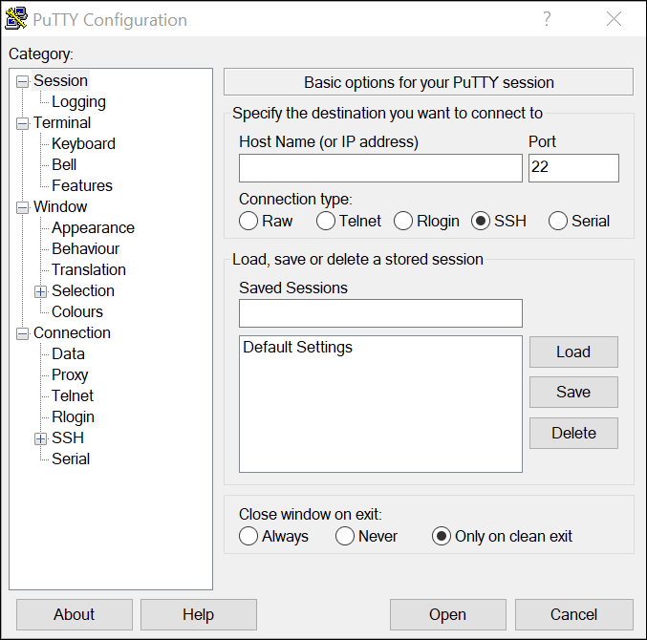
Step 2. Enable logging in the terminal software and assign a name and file location to save the log file. The figure displays that All session output will be captured to the file specified (i.e., MySwitchLogs).
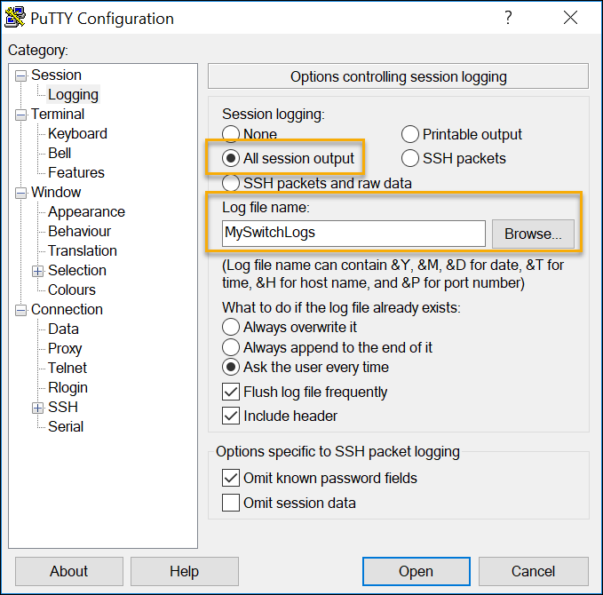
Step 3. Execute the show running-config or show startup-config command at the privileged EXEC prompt. Text displayed in the terminal window will be placed into the chosen file.
Sw-Floor-1# show running-config
Building configuration...
(output omitted)
Step 4. Disable logging in the terminal software. The figure shows how to disable logging by choosing the None session logging option.
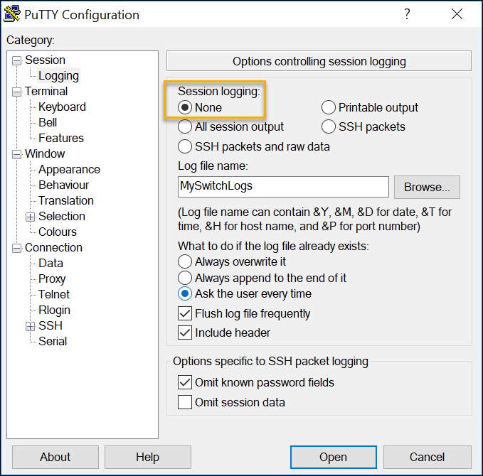
The text file created can be used as a record of how the device is currently implemented. The file could require editing before being used to restore a saved configuration to a device.
To restore a configuration file to a device:
Step 1. Enter global configuration mode on the device.
Step 2. Copy and paste the text file into the terminal window connected to the switch.
The text in the file will be applied as commands in the CLI and become the running configuration on the device. This is a convenient method of manually configuring a device.

1.2.6 Ports and Addresses
IP Addresses
Congratulations, you have performed a basic device configuration! Of course, the fun is not over yet. If you want your end devices to communicate with each other, you must ensure that each of them has an appropriate IP address and is correctly connected. You will learn about IP addresses, device ports and the media used to connect devices in this topic.
The use of IP addresses is the primary means of enabling devices to locate one another and establish end-to-end communication on the internet. Each end device on a network must be configured with an IP address. Examples of end devices include these:
- Computers (work stations, laptops, file servers, web servers)
- Network printers
- VoIP phones
- Security cameras
- Smart phones
- Mobile handheld devices (such as wireless barcode scanners)
The structure of an IPv4 address is called dotted decimal notation and is represented by four decimal numbers between 0 and 255. IPv4 addresses are assigned to individual devices connected to a network.
Note: IP in this course refers to both the IPv4 and IPv6 protocols. IPv6 is the most recent version of IP and is replacing the more common IPv4.
With the IPv4 address, a subnet mask is also necessary. An IPv4 subnet mask is a 32-bit value that differentiates the network portion of the address from the host portion. Coupled with the IPv4 address, the subnet mask determines to which subnet the device is a member.
The example in the figure displays the IPv4 address (192.168.1.10), subnet mask (255.255.255.0), and default gateway (192.168.1.1) assigned to a host. The default gateway address is the IP address of the router that the host will use to access remote networks, including the internet.
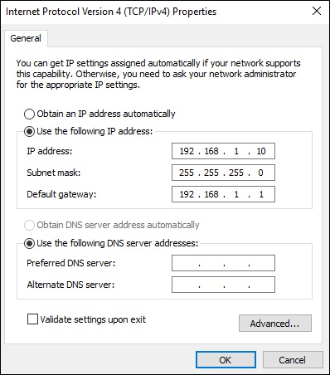
IPv6 addresses are 128 bits in length and written as a string of hexadecimal values. Every four bits is represented by a single hexadecimal digit; for a total of 32 hexadecimal values. Groups of four hexadecimal digits are separated by a colon (:) . IPv6 addresses are not case-sensitive and can be written in either lowercase or uppercase.
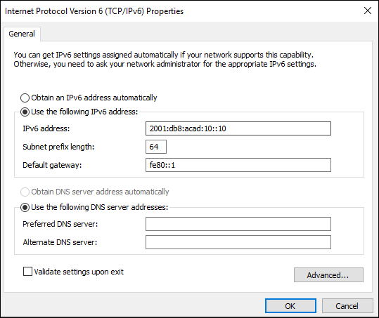

Interfaces and Ports
Network communications depend on end user device interfaces, networking device interfaces, and the cables that connect them. Each physical interface has specifications, or standards, that define it. A cable connecting to the interface must be designed to match the physical standards of the interface. Types of network media include twisted-pair copper cables, fiber-optic cables, coaxial cables, or wireless, as shown in the figure.
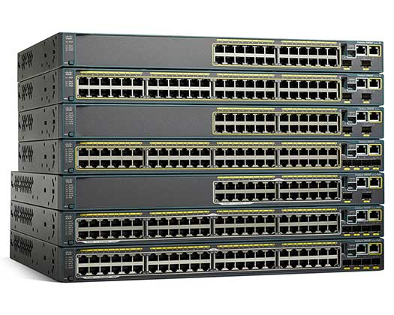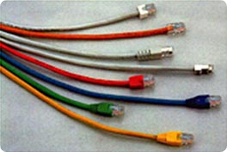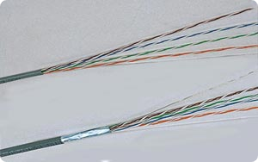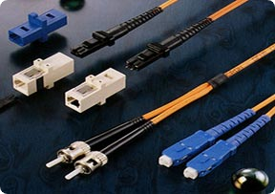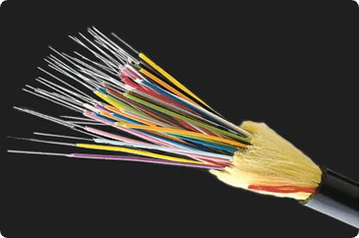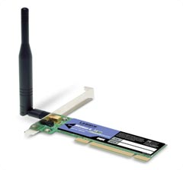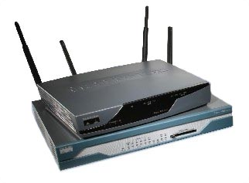

Different types of network media have different features and benefits. Not all network media have the same characteristics. Not all media are appropriate for the same purpose. These are some of the differences between various types of media:
- Distance the media can successfully carry a signal
- Environment in which the media is to be installed
- Amount of data and the speed at which it must be transmitted
- Cost of the media and installation
Not only does each link on the internet require a specific network media type, but each link also requires a particular network technology. For example, Ethernet is the most common local-area network (LAN) technology used today. Ethernet ports are found on end-user devices, switch devices, and other networking devices that can physically connect to the network using a cable.
Cisco IOS Layer 2 switches have physical ports for devices to connect. These ports do not support Layer 3 IP addresses. Therefore, switches have one or more switch virtual interfaces (SVIs). These are virtual interfaces because there is no physical hardware on the device associated with it. An SVI is created in software.
The virtual interface lets you remotely manage a switch over a network using IPv4 and IPv6. Each switch comes with one SVI appearing in the default configuration "out-of-the-box." The default SVI is interface VLAN1.
Note: A Layer 2 switch does not need an IP address. The IP address assigned to the SVI is used to remotely access the switch. An IP address is not necessary for the switch to perform its operations.

1.2.7 Configure IP Addressing
Manual IP Address Configuration for End Devices
Much like you need your friends' telephone numbers to text or call them, end devices in your network need an IP address so that they can communicate with other devices on your network. In this topic, you will implement basic connectivity by configuring IP addressing on switches and PCs.
IPv4 address information can be entered into end devices manually, or automatically using Dynamic Host Configuration Protocol (DHCP).
To manually configure an IPv4 address on a Windows host, open the Control Panel > Network Sharing Center > Change adapter settings and choose the adapter. Next right-click and select Properties to display the Local Area Connection Properties, as shown in the figure.
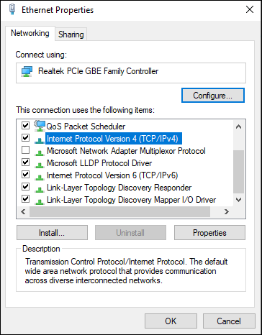
Highlight Internet Protocol Version 4 (TCP/IPv4) and click Properties to open the Internet Protocol Version 4 (TCP/IPv4) Properties window, shown in the figure. Configure the IPv4 address and subnet mask information, and default gateway.
Note: IPv6 addressing and configuration options are similar to IPv4.
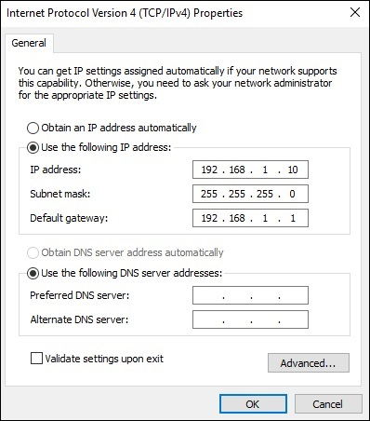

Automatic IP Address Configuration for End Devices
End devices typically default to using DHCP for automatic IPv4 address configuration. DHCP is a technology that is used in almost every network. The best way to understand why DHCP is so popular is by considering all the extra work that would have to take place without it.
In a network, DHCP enables automatic IPv4 address configuration for every end device that is DHCP-enabled. Imagine the amount of time it would take if every time you connected to the network, you had to manually enter the IPv4 address, the subnet mask, the default gateway, and the DNS server. Multiply that by every user and every device in an organization and you see the problem. Manual configuration also increases the chance of misconfiguration by duplicating another device’s IPv4 address.
As shown in the figure, to configure DHCP on a Windows PC, you only need to select Obtain an IP address automatically and Obtain DNS server address automatically. Your PC will search out a DHCP server and be assigned the address settings necessary to communicate on the network.
Note: IPv6 uses DHCPv6 and SLAAC (Stateless Address Autoconfiguration) for dynamic address allocation.
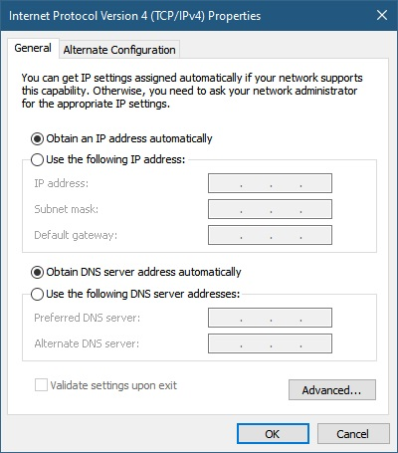

Switch Virtual Interface Configuration
To access the switch remotely, an IP address and a subnet mask must be configured on the SVI. To configure an SVI on a switch, use the interface vlan 1 global configuration command. Vlan 1 is not an actual physical interface but a virtual one. Next assign an IPv4 address using the ip address ip-address subnet-mask interface configuration command. Finally, enable the virtual interface using the no shutdown interface configuration command.
After these commands are configured, the switch has all the IPv4 elements ready for communication over the network.
Note: Similar to a Windows hosts, switches configured with an IPv4 address will typically also need to have a default gateway assigned. This can be done using the ip default-gateway ip-address global configuration command. The ip-address parameter would be the IPv4 address of the local router on the network, as shown in the example. However, in this module you will only be configuring a network with switches and hosts. Routers will be introduced later.
Sw-Floor-1# configure terminal
Sw-Floor-1(config)# interface vlan 1
Sw-Floor-1(config-if)# ip address 192.168.1.20 255.255.255.0
Sw-Floor-1(config-if)# no shutdown
Sw-Floor-1(config-if)# exit
Sw-Floor-1(config)# ip default-gateway 192.168.1.1

1.3 Protocols and Models
1.3.1 Introduction
- In networking, a protocol defines the rules that both the sender and receiver andall intermediate devices need to follow to be able to communicate effectively.
- A protocol provides a communication service that the process use to exchange messages.
- When communication is simple, we may need only one simple protocol.
- When the communication is complex, we may need to divide the task between different layers, in which case we need a protocol at each layer, or protocol layering.
- Protocol layering is that it allows us to separate the services from the implementation.
- A layer needs to be able to receive a set of services from the lower layer and to give the services to the upper layer.
- Any modification in one layer will not affect the other layers.

Basic Elements of Layered Architecture
- Service: It is a set of actions that a layer provides to the higher layer.
- Protocol: It defines a set of rules that a layer uses to exchange the information with peer entity. These rules mainly concern about both the contents and order of the messages used.

- Interface: It is a way through which the message is transferred from one layer to another layer.

Features of Protocol Layering
- It decomposes the problem of building a network into more manageable components.
- It provides a more modular design.

Principles of Protocol Layering
- The first principle dictates that if we want bidirectional communication, we need to make each layer so that it is able to perform two opposite tasks, one in each direction.
- The second principle that we need to follow in protocol layering is that the two objects under each layer at both sites should be identical.

1.3.2 PROTOCOLS AND PROTOCOL SUITE (INTERNET ARCHITECTURE)

The TCP/IP architecture is also called as Internet architecture.
It is developed by the US Defense Advanced Research Project Agency (DARPA)for its packet switched network (ARPANET).
TCP/IP is a protocol suite used in the Internet today. It is a 5-layer model. The layers of TCP/IP are

- Application layer
- Transport Layer (TCP/UDP)
- Network Layer
- Datalink Layer
- Physical Layer

1.3.3 Standards
Various organizations have different responsibilities for promoting and creating standards for the internet and TCP/IP protocol.
The figure displays standards organizations involved with the development and support of the internet.
The figure shows standards organizations involved with the development and support of the internet. At the top of the figure is the Internet Society (ISOC) logo. A line underneath connects to the Internet Architecture Board (IAB) logo. Underneath and to the left is the Internet Engineering Task Force (IETF) and to the right is the Internet Research Task Force (IRTF). Below the IETF is the Internet Engineering Steering Group (IESG) and below that are working group #1 and working group #2. Below the IRTF is the Internet Research Steering Group (IRSG) and below that are research group #1 and research group #2. Text at the bottom reads: Internet Society (ISOC) - Responsible for promoting the open development and evolution of internet use throughout the world. Internet Architecture Board (IAB) - Responsible for the overall management and development of internet standards. Internet Engineering Task Force (IETF) - Develops, updates, and maintains internet and TCP/IP technologies. This includes the process and documents for developing new protocols and updating existing protocols, which are known as Request for Comments (RFC) documents. Internet Research Task Force (IRTF) - Focused on long-term research related to internet and TCP/IP protocols such as Anti-Spam Research Group (ASRG), Crypto Forum Research Group (CFRG), and Peer-to-Peer Research Group (P2PRG).

Internet Society (ISOC)
Internet Architecture Board (IAB)
Internet Engineering
Task Force (IETF)
Internet Engineering Steering Group (IESG)
Internet Research
Task Force (IRTF)
Internet Research Steering Group (IRSG)
Working
Group #1
Working
Group #2
Research
Group #1
Research
Group #2

- Internet Society (ISOC) - Responsible for promoting the open development and evolution of internet use throughout the world.
- Internet Architecture Board (IAB) - Responsible for the overall management and development of internet standards.
- Internet Engineering Task Force (IETF)- Develops, updates, and maintains internet and TCP/IP technologies. This includes the process and documents for developing new protocols and updating existing protocols, which are known as Request for Comments (RFC) documents.
- Internet Research Task Force (IRTF)- Focused on long-term research related to internet and TCP/IP protocols such as Anti-Spam Research Group (ASRG), Crypto Forum Research Group (CFRG), and Peer-to-Peer Research Group (P2PRG).
This displays standards organizations involved with the development and support of TCP/IP and include IANA and ICANN.
This shows the standards organizations involved with the development and support of TCP/IP. Image shows ICANN on the right with an arrow pointing to IANA. Below IANA are three arrows leading to IP addresses, domain names, and TCP/UDP port numbers. Text at the bottom reads: Internet Corporation for Assigned Names and Numbers (ICANN) - Based in the United States, ICANN coordinates IP address allocation, the management of domain names, and assignment of other information used in TCP/IP protocols. Internet Assigned Numbers Authority (IANA) - Responsible for overseeing and managing IP address allocation, domain name management, and protocol identifiers for ICANN.
IANA
ICANN
Domain Names
TCP/UDP Port Numbers
IP Addresses

- Internet Corporation for Assigned Names and Numbers (ICANN)- Based in the United States, ICANN coordinates IP address allocation, the management of domain names, and assignment of other information used in TCP/IP protocols.
- Internet Assigned Numbers Authority (IANA)- Responsible for overseeing and managing IP address allocation, domain name management, and protocol identifiers for ICANN.

1.3.3 Reference Models

The Benefits of Using a Layered Model
You cannot actually watch real packets travel across a real network, the way you can watch the components of a car being put together on an assembly line. so, it helps to have a way of thinking about a network so that you can imagine what is happening. A model is useful in these situations.
Complex concepts such as how a network operates can be difficult to explain and understand. For this reason, a layered model is used to modularize the operations of a network into manageable layers.
These are the benefits of using a layered model to describe network protocols and operations:
- Assisting in protocol design because protocols that operate at a specific layer have defined information that they act upon and a defined interface to the layers above and below
- Fostering competition because products from different vendors can work together
- Preventing technology or capability changes in one layer from affecting other layers above and below
- Providing a common language to describe networking functions and capabilities
There are two layered models that are used to describe network operations:
- Open System Interconnection (OSI) Reference Model
- TCP/IP Reference Model
At the top of the image are two LANs connected via a WAN with the text: A networking model is only a representation of a network operation. The model is not the actual network. Underneath are the OSI and TCP/IP model layers and protocols. The seven layers of the OSI model from top to bottom and their associated protocols are: application, presentation, session (protocols at the top three layers are HTTP, DNS, DHCP, and FTP), transport (TCP and UDP), network (IPv4, IPv6, ICMPv4, and ICMPv6), data link, and physical (protocols at the bottom two layers are Ethernet, WLAN, SONET, and SDH). The four layers of the TCP/IP model from top to bottom and their associated protocols are: application (HTTP, DNS, DHCP, and FTP), transport (TCP and UDP), Internet (IPv4, IPv6, ICMPv4, and ICMPv6), and network access (Ethernet, WLAN, SONET, and SDH).

1.3.4 Data Encapsulation

Segmenting Messages
Knowing the OSI reference model and the TCP/IP protocol model will come in handy when you learn about how data is encapsulated as it moves across a network. It is not as simple as a physical letter being sent through the mail system.
In theory, a single communication, such as a video or an email message with many large attachments, could be sent across a network from a source to a destination as one massive, uninterrupted stream of bits. However, this would create problems for other devices needing to use the same communication channels or links. These large streams of data would result in significant delays. Further, if any link in the interconnected network infrastructure failed during the transmission, the complete message would be lost and would have to be retransmitted in full.
A better approach is to divide the data into smaller, more manageable pieces to send over the network. Segmentation is the process of dividing a stream of data into smaller units for transmissions over the network. Segmentation is necessary because data networks use the TCP/IP protocol suite send data in individual IP packets. Each packet is sent separately, similar to sending a long letter as a series of individual postcards. Packets containing segments for the same destination can be sent over different paths.
This leads to segmenting messages having two primary benefits:
- Increases speed - Because a large data stream is segmented into packets, large amounts of data can be sent over the network without tying up a communications link. This allows many different conversations to be interleaved on the network called multiplexing.
- Increases efficiency -If a single segment is fails to reach its destination due to a failure in the network or network congestion, only that segment needs to be retransmitted instead of resending the entire data stream.

Sequencing
The challenge to using segmentation and multiplexing to transmit messages across a network is the level of complexity that is added to the process. Imagine if you had to send a 100-page letter, but each envelope could only hold one page. Therefore, 100 envelopes would be required and each envelope would need to be addressed individually. It is possible that the 100-page letter in 100 different envelopes arrives out-of-order. Consequently, the information in the envelope would need to include a sequence number to ensure that the receiver could reassemble the pages in the proper order.
In network communications, each segment of the message must go through a similar process to ensure that it gets to the correct destination and can be reassembled into the content of the original message, as shown in the figure. TCP is responsible for sequencing the individual segments.
1.3.5 Data Access

Protocol Data Units
As application data is passed down the protocol stack on its way to be transmitted across the network media, various protocol information is added at each level. This is known as the encapsulation process.
Note: Although the UDP PDU is called datagram, IP packets are sometimes also referred to as IP datagrams.
The form that a piece of data takes at any layer is called a protocol data unit (PDU). During encapsulation, each succeeding layer encapsulates the PDU that it receives from the layer above in accordance with the protocol being used. At each stage of the process, a PDU has a different name to reflect its new functions. Although there is no universal naming convention for PDUs, in this course, the PDUs are named according to the protocols of the TCP/IP suite.

Addresses
As you just learned, it is necessary to segment messages in a network. But those segmented messages will not go anywhere if they are not addressed properly. This topic gives an overview of network addresses. You will also get the chance to use the Wireshark tool, which will help you to ‘view’ network traffic.
The network and data link layers are responsible for delivering the data from the source device to the destination device. As shown in the figure, protocols at both layers contain a source and destination address, but their addresses have different purposes:
- Network layer source and destination addresses - Responsible for delivering the IP packet from the original source to the final destination, which may be on the same network or a remote network.
- Data link layer source and destination addresses - Responsible for delivering the data link frame from one network interface card (NIC) to another NIC on the same network.
The figure shows the addressing and labeling used at various layers of the OSI model for delivering data. Starting from left to right, it shows: the physical layer provides timing and synchronization bits; the data link layer provides destination and source physical addresses; the network layer provides destination and source logical network addresses; the transport layer provides destination and source process number (ports); and the upper layers provide encoded application data.
Physical
Data Link
Network
Transport
Upper Layers
Timing and synchronization bits
Destination and source physical addresses
Destination and source logical network addresses
Destination and source process number (ports)
Encoded application data

